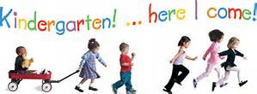

Documents you will need to bring to registration:
- Social Security Card
- Certified Birth Certificate
- Immunization Certificate
- Preventative Health Care / Physical Exam
- Current Vision Exam
- Current Dental Exam

Kindergarten is a very exciting time for children and their families. We look forward to meeting you and making this transition as smooth as possible.

